Currently, Big Mountain charges $81 for an Adult weekend ticket. We assumed that the expected number of visitors over the season is 350,000 and visitors ski for five days on average.

We listed some options as follows:

1. Permanently closing down up to 10 of the least used runs. This doesn't impact any other resort statistics.
2. Increase the vertical drop by adding a run to a point 150 feet lower down but requiring the installation of an additional chair lift to bring skiers back up, without additional snow making coverage
3. Same as number 2, but adding 2 acres of snow making cover
4. Increase the longest run by 0.2 mile to boast 3.5 miles length, requiring an additional snow making coverage of 4 acres

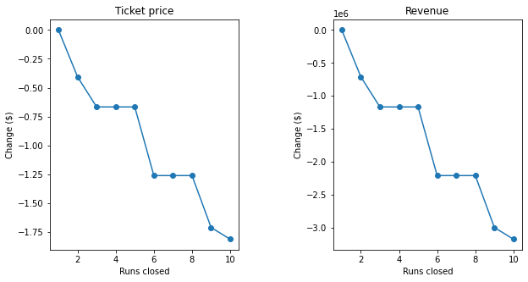As you can see in the figure on the right, in the first scenario, closing one run makes no difference, closing 2 reduces $0.4, closing 3/4/5 reduces $0.7 and closing more leads to a large drop. This scenario may be able to reduce the operating cost as some runs are permanently closed but it also make both the ticket price and revenue decreased. In addition, reducing runs will lose competitiveness s visitors obviously would not like that.

The scenario 2 increases support for ticket price by $8.61, which will be $89.61 and the scenario 3 increases support for ticket price by $9.90, which will be $90.90. These two scenarios would be looking good to increase the ticket price as there are still quite a few resorts with a greater drop than Big Mountain. However, it could be a burden to install of an additional chair lift as the maintenance cost also will be increased. In addition, Big Mountain is very high up the league table of snow making area, it is not required to have more snow making area with the same reason. As you can see in the below figures, the current ticket price of Big Mountain is higher than the average in nationwide and the most expensive in Montana state. So if the price would increase to around $90, it could be a burden for visitors to stay several days for skiing.

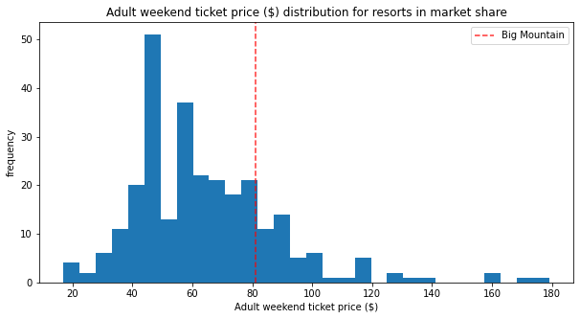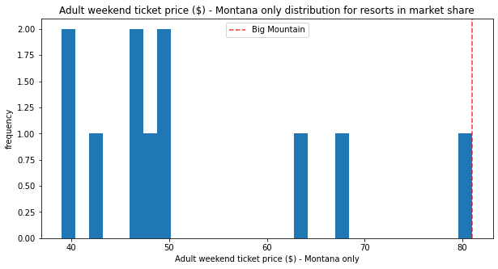

In the meantime, the last scenario is expected to make no difference in ticket price for increasing the longest run by 0.2 miles and guaranteeing its snow coverage by adding 4 acres of snow making capability. This means that you can make visitors more attracted by its expansion of facility without additional costs as there are some resorts with more runs in the market even though Big Mountain compares well for the number of runs currently. At the same time, it also means that, if you decide to increase the ticket price a few more dollars but still lower than $89 which is from scenario 2, it would be an additional revenue.

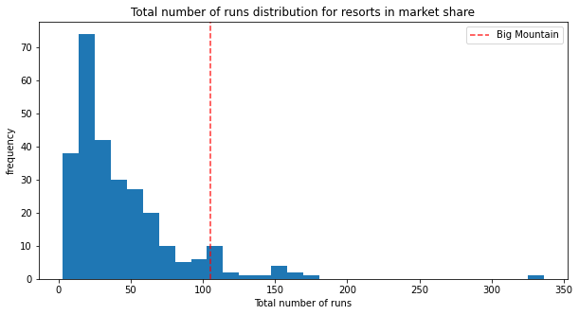

So I would recommend the scenario 4.